GLOBAL VILLAGE ENERGY PARTNERSHIP (GVEP) – GIS & KM Project by Shri Shakti, Janastu and Mapunity

Project Aim

Mapunity’s aim is to create a software platform for mapping/monitoring the non-conventional energy resources in remote villages that cannot be economically serviced by conventional grid power. The project aim is to build capacity with the officials and other stakeholders for planning and implementing remote village electrification projects using the GIS and Knowledge Management (KM) tools and disseminating such information to stakeholders.

Application Capabilities of Mapunity for remote villages GIS
The application has the following capabilities:

- The user can view, browse and navigate across the maps
- When the user views the map, he/she will be shown the un-electrified villages as points (balloons) on the map
- By clicking on a village, the user will be informed about the energy options available along with census and survey information
- Use can view the energy profiles across all the mapped villages by choosing a relevant energy option (such as wind, solar and hydel)
- Users can also view the preferred energy sources for each village.
The application could be used to monitor the energy resources in rural regions. In addition, it can also help decision makers find the appropriate energy resource by suggesting choices.
The application can be improved further as a broad platform on which various participants such as administrators, decision makers and villagers could interact, maintain and add to the information to keep it update for their needs.

The technical approach used by Mapunity for building the GIS for remote village electrification is described in detail in Annexure I appended to this note.

Project status at Mapunity’s end

As part of the GVEP program, Mapunity has undertaken the task of mapping the Census Data and availability of energy resources in the remote villages. A model web application has been created to allow lay users to query and retrieve the information related to the maps, census data and energy resources. The application can be accessed and viewed using internet browsers (Mozilla Firefox preferred).
Web link: http://mapunity.org/projects/gvep

The states of Assam and Chattisgarh are being mapped in the pilot study.

- In the state of Assam (total 23 districts), 12 remote villages of Assam have been mapped in two districts. Census data 2001 for the whole state is available. District maps for five districts are available – Morigaon, Goalpara, Dhuburi, Nagaoan and Golaghat. We have abandoned the efforts to obtain Maps for the other districts in Assam as many of those are restricted due to insurgency / militancy problems in the state. Out of the 12 remote villages, 8nos are in Morigaon and 4nos are in Golaghat.
- District maps for 14 districts in C’garh have been obtained (Koriya, Bastar, Korba, Janjgir – Champa, Surguja, Mahasmund, Bilaspur, Dantewara, Durg, Rajnandgaon, Raipur, Raigarh, Kanker, Dhamtari) out of total of 16 districts. Maps for districts of Jashpur and Kawagdhar are pending.
- In the state of Chattisgarh 594 villages (out of 1250 nos remote villages identified by CREDA) have been mapped along with information about alternate energy potential (wind and solar – dummy data). The rest of the villages could not be mapped as there were mismatches between the 1991 census codes use by CREDA and 2001 census codes available in the census data files. These villages can be mapped after CREDA sorts out the 1991 and 2001 census codes.
- Census data for the year 2001 are also linked to the villages with the key fields (village name, block name, district name, latitude, longitude, total population, no. of households and census code) given in the bookmark.
- 200 villages have been electrified through Solar PV power plants and the data for the same with details on monitoring of the operation and maintenance were made available by CREDA. Again, there were mismatches in the names of the villages or their spelling and the census codes and only 45 villages could be mapped using the 2001 census codes. The rest can be done after CREDA sorts out the data files.
- The village survey data (for 12 sample village in Assam) and for 10 villages in C’garh (sample data) is also made available through a hyperlink to get all the survey data gathered for planning the village electrification.
- The detailed census data RELEVANT for planning village electrification is also made available through another hyperlink.
- The village location maps for the 12 villages in Assam and 10 villages in C’garh are made available through hyperlinks.

Demo screen shot: Chattisgarh – Remote Village Locations
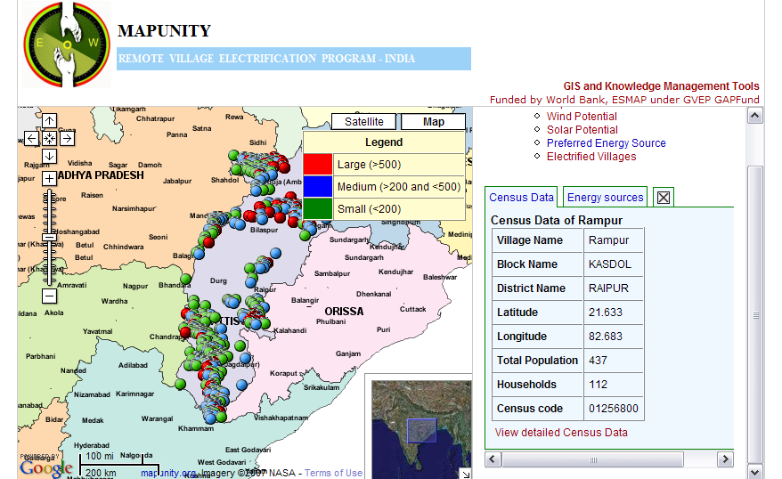

The population of remote villages is classified into Small ( < 200 persons), Medium (>200 and < 500) and Large (> 500) and have been COLOUR coded.

Demo Screenshot: Chattisgarh Wind and Solar Potential for Remote Villages from NASA Database

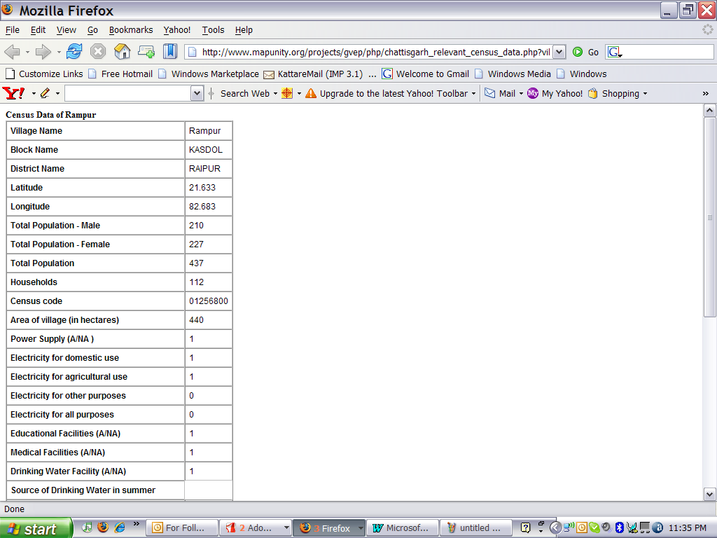
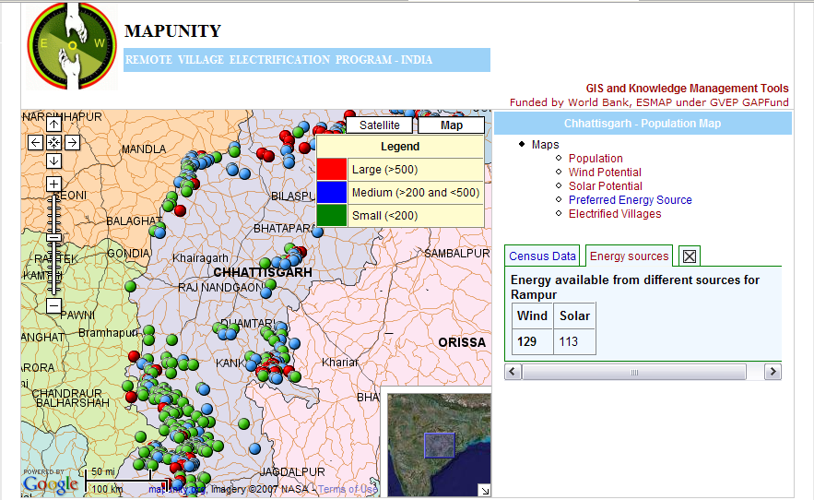

For each category of energy resource (ie wind, solar or hydel), the availability is classified into Good, Fair and Marginal. Presently, the data displayed is dummy data and work is going on to allow extraction of information into Mapunity from the online database of NASA for Surface Meteorology and Solar Energy which is provided for RETScreen Software.

Demo Screen Shot Showing detailed census data relevant for village electrification

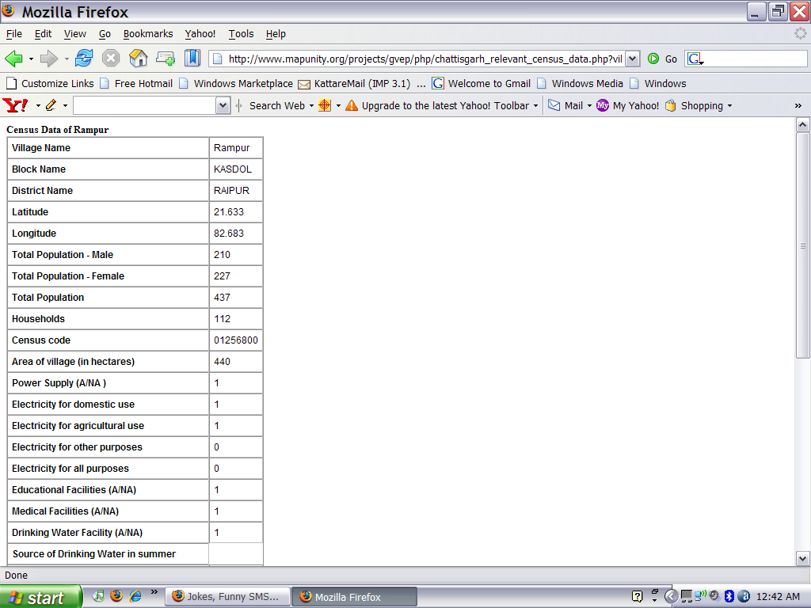

Demo Screen Shot showing the detials of Monitoring of village electrification for Rampur village in Chattisgarh as being monitored by CREDA

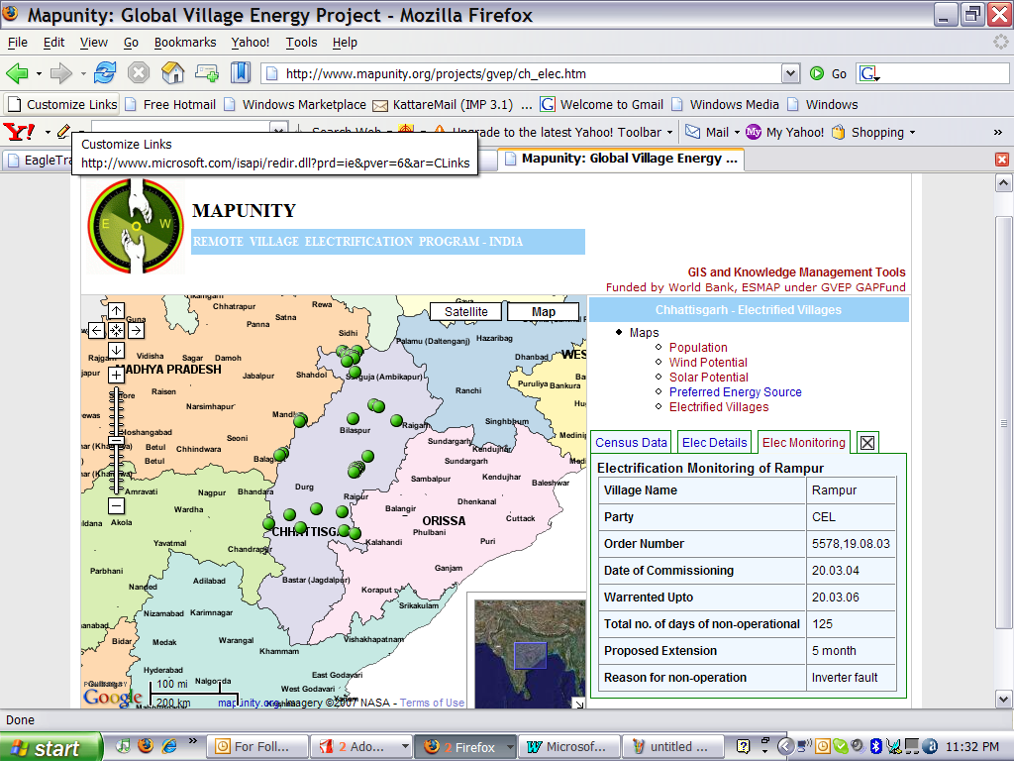

Demo Screen Shot for remote village in Assam giving the key census data
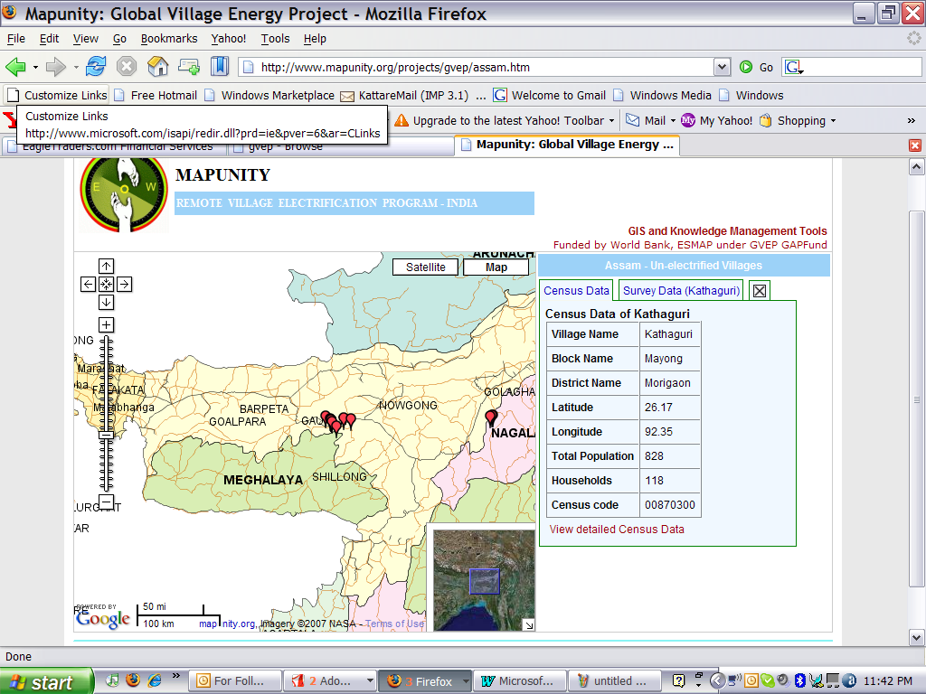

Demo Screen Shot of “View detailed Census Data” for village Kathaguri is given in the following pages. The format of the survey is as specified by MNES and has been adapted suitably for online data entry.

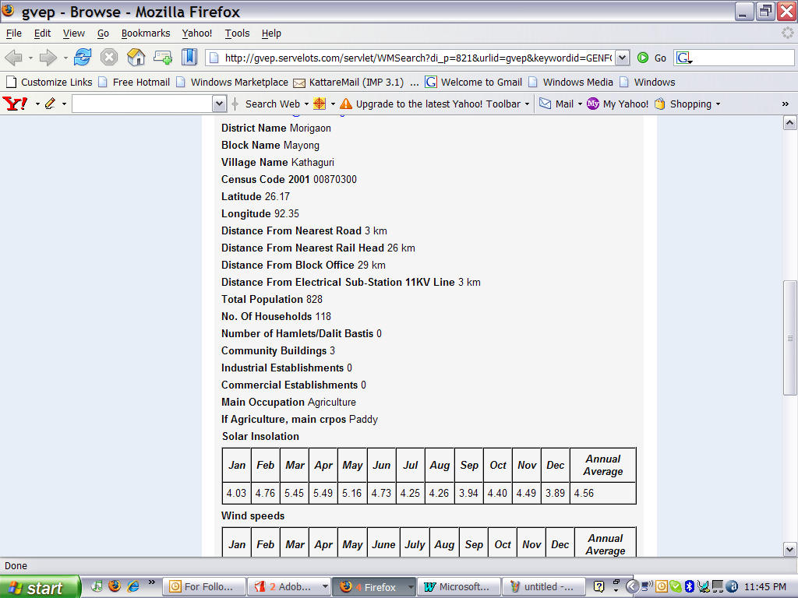
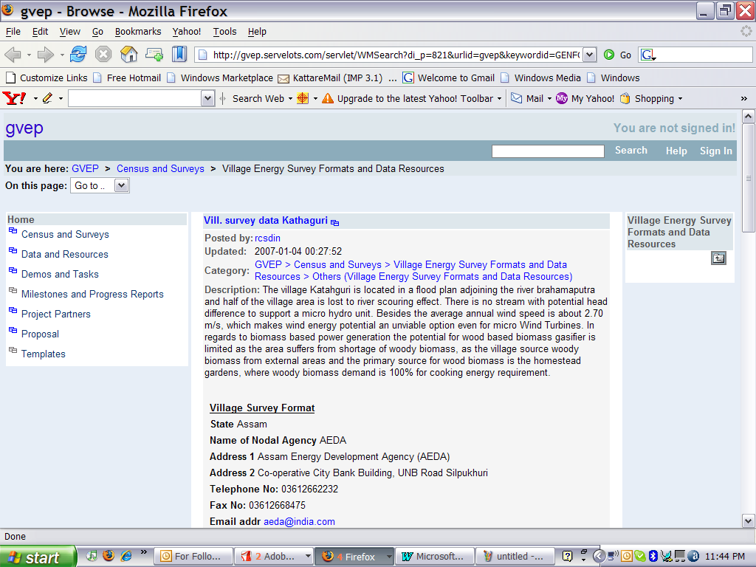

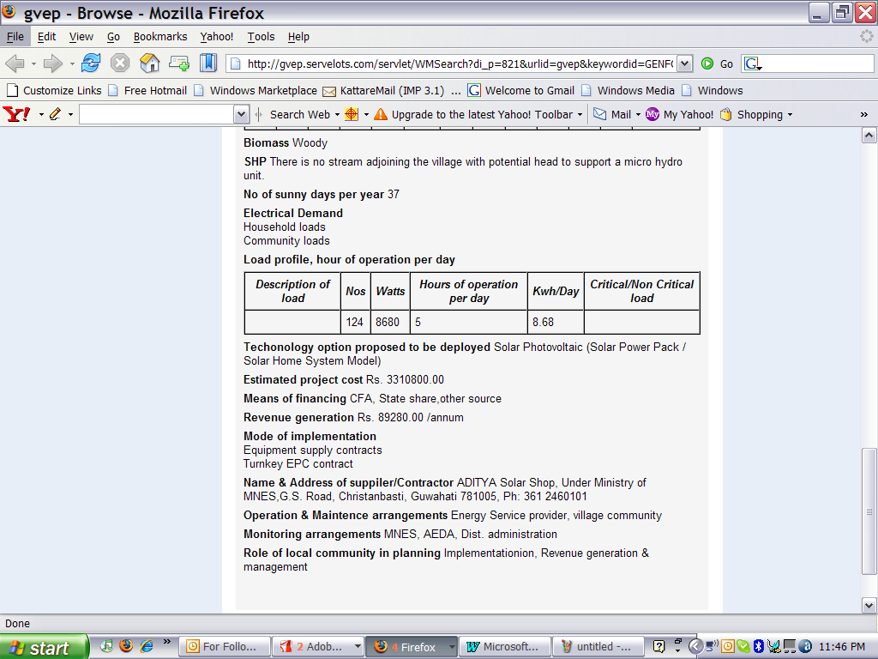
ANNEXURE I

Technical approach by Mapunity for remote village GIS

Preparing Base Information
Maps were collected from various forms such as GPS points and paper maps. The paper maps were used as base for mapping the villages and other administrative units. The maps were scanned and converted to raster images. The scanned images (map) however are not planimetrically true to ground features and the maps did not have any inherent information about the geographic coordinates. In order to measure/estimate areas or points from the maps, geometric errors have to be rectified and the data have to be made planimetrically true to the standard maps.
Map rectification was done using the Ground Control Points (GCP). The GCPs were collected using GPS. Those points were used as reference on which the maps were rectified through first order polynomial projection. The accuracy was verified by superimposing the GCPs on the projected map using standard image analysis software.

In addition, accuracy was verified by means of checking the RMS errors. The error distribution was consistent across the maps. The process was repeated all the individual paper maps. Finally, the maps were stitched together using an image mosaic tool.
Creation of Vector Maps
The map derived from the above process was treated as a base map. The vector lines/polygons were drawn on the base map using GIS software. In this process, various administrative and natural features were delineated. The administrative features include district and taluk boundaries along with their centroids. Among the natural features, the rivers were digitized after the creation of vector maps. They had undergone a quality check by verifying the map for dangles, pseudo polygons and missing labels. Once all these are verified the vector maps are converted to ESRI shapefile.
Map Composition & Tiling
The vector maps are not very amenable for viewing using commonly available software. Hence, they were composed and converted into raster images. During map composition, each vector layer was given an appropriate style & symbology. Later the layers were stacked in the right order to create the impression of a complete map.
Once the style and order of stack was standardized, they were subjected to the tilemaking process. The tile making process essentially involves slicing the large raster images into pieces of images with dimensions 256 X 256 pixel or lesser. The tiling is required because it makes the map rendering by the client software (ie browser) easier by serving small images instead of large images (that cannot be loaded due to memory constraints).
In order to create the tiles, Mapunity has written a programme called "TileMaker". The TileMaker can import many shape files and styles and create tiles at regular geographic intervals in the form of any standard image type such as png/jpg at different specified zoom levels. The TileMaker essentially loads the shapefiles and styles, and composes the map as specified by the user and renders the map as an image. The image later gets sliced into various tiles as specified by the user (ie 256 X 256 pixels).
Deploying the Tiles on server
The tiles were exported to the standard http server (i.e., apache), they were served as tiles to the browser client.

-------------------------------------

